FINAL EXAM REFERENCE CHARTS- DO NOT WRITE ON.
Electronegativities
H
2.2
Li | Be |  |  |  |  |  |  |  |  |  |  | B | C | N | O | F
1.0 | 1.6 |  |  |  |  |  |  |  |  |  |  | 2.0 | 2.6 | 3.0 | 3.4 | 4.0
Na | Mg |  |  |  |  |  |  |  |  |  |  | Al | Si | P | S | Cl
0.9 | 1.3 |  |  |  |  |  |  |  |  |  |  | 1.6 | 1.9 | 2.2 | 2.6 | 3.2
K | Ca | Sc | Ti | V | Cr | Mn | Fe | Co | Ni | Cu | Zn | Ga | Ge | As | Se | Br
0.8 | 1.0 | 1.4 | 1.5 | 1.6 | 1.7 | 1.6 | 1.9 | 1.9 | 1.9 | 2.0 | 1.7 | 1.8 | 2.0 | 2.2 | 2.5 | 3.0
Rb | Sr | Y | Zr | Nb | Mo | Tc | Ru | Rh | Pd | Ag | Cd | In | Sn | Sb | Te | I
0.8 | 1.0 | 1.2 | 1.3 | 1.6 | 2.2 | 1.9 | 2.2 | 2.3 | 2.2 | 1.9 | 1.7 | 1.8 | 1.9 | 2.0 | 2.1 | 2.7
Cs | Ba | La | Hf | Ta | W | Re | Os | Ir | Pt | Au | Hg | Tl | Pb | Bi | Po | At
0.8 | 0.9 | 1.1 | 1.3 | 1.5 | 2.4 | 1.9 | 2.2 | 2.2 | 2.3 | 2.5 | 2.0 | 1.8 | 2.1 | 2.0 | 2.0 | 2.2
Fr | Ra | Ac
0.7 | 0.9 | 1.1

Orbital Filling Order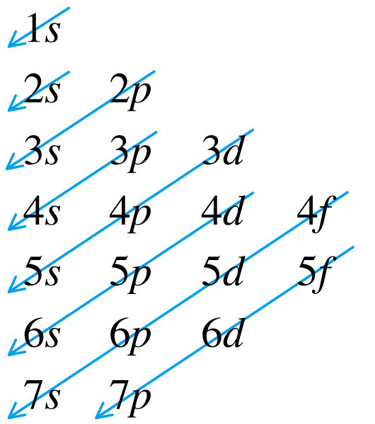

Common Ions of Transition Metals and Groups 13 and 14
Group 4 | Group 5 | Group 6 | Group 7 | Group 8 | Group 9 | Group 10 | Group 11 | Group 12 | Group 13 | Group 14
Ti²⁺  Ti³⁺  Ti⁴⁺ | V²⁺  V³⁺  V⁴⁺  V⁵⁺ | Cr²⁺  Cr³⁺  Cr⁶⁺ | Mn²⁺  Mn³⁺  Mn⁴⁺  Mn⁷⁺ | Fe²⁺  Fe³⁺ | Co²⁺  Co³⁺ | Ni²⁺  Ni³⁺ | Cu⁺  Cu²⁺ | Zn²⁺ | Ga³⁺
Zr⁴⁺ | Nb³⁺  Nb⁵⁺ | Mo³⁺  Mo⁶⁺ | Tc⁴⁺  Tc⁶⁺  Tc⁷⁺ | Ru³⁺ | Rh³⁺ | Pd²⁺  Pd⁴⁺ | Ag⁺ | Cd²⁺ | In³⁺ | Sn²⁺  Sn⁴⁺
Hf⁴⁺ | Ta⁵⁺ | W⁶⁺ | Re⁴⁺  Re⁶⁺  Re⁷⁺ | Os³⁺  Os⁴⁺ | Ir³⁺  Ir⁴⁺ | Pt²⁺  Pt⁴⁺ | Au⁺  Au³⁺ | Hg₂²⁺  Hg²⁺ | Tl⁺  Tl³⁺ | Pb²⁺  Pb⁴⁺

Metric Prefixes

Prefix | Unit Abbreviation | Exponential Multiplier
Giga | G | 10⁹
Mega | M | 10⁶
Kilo | k | 10³
Hecto | H | 10²
 |  | 1
Deci | d | 10⁻¹
Centi | c | 10⁻²
Milli | m | 10⁻³
Micro | µ | 10⁻⁶
Nano | n | 10⁻⁹
Pico | p | 10⁻¹²

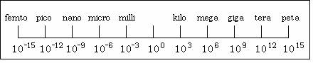

Common Polyatomic Ions
Ion | Name | Ion | Name
C₂H₃O₂⁻ or  CH₃COO⁻ | acetate | OH⁻ | hydroxide
NH₄⁺ | ammonium | IO₄⁻ | periodate
CH₃NH₃⁺ | Methylammonium | IO₃⁻ | iodate
AsO₄³⁻ | arsenate | Hg₂²⁺ | mercury(I)
N₃⁻ | azide | NO₃⁻ | nitrate
BrO₃⁻ | bromate | NO₂⁻ | nitrite
CO₃²⁻ | carbonate | C₂O₄²⁻ | oxalate
HCO₃⁻ | hydrogen carbonate  or  bicarbonate | MnO₄⁻ | permanganate
ClO₄⁻ | perchlorate | O₂²⁻ | peroxide
ClO₃⁻ | chlorate | PO₄³⁻ | phosphate
ClO₂⁻ | chlorite | HPO₄²⁻ | hydrogen phosphate
ClO⁻ | hypochlorite | H₂PO₄⁻ | dihydrogen phosphate
CrO₄²⁻ | chromate | SO₃²⁻ | sulfite
Cr₂O₇²⁻ | dichromate | SO₄²⁻ | sulfate
CN⁻ | cyanide | HSO₄⁻ | hydrogen sulfate  or  bisulfate
SCN⁻ | thiocyanate | UO₂²⁺ | uranyl

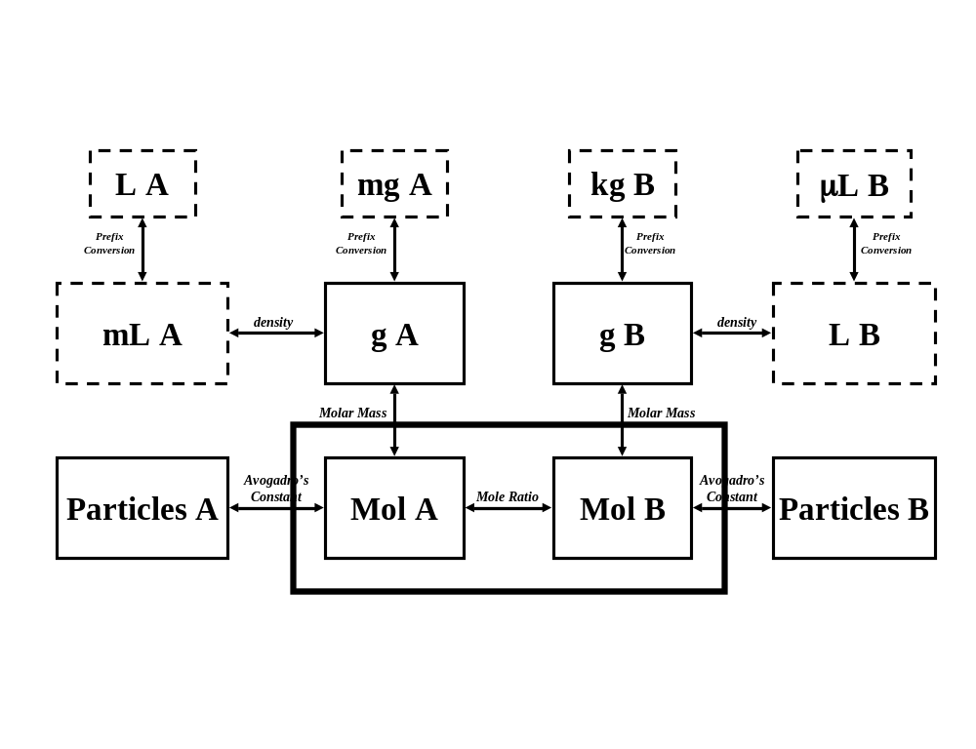
Element  Name | Symbol | Atomic  Number | Atomic  Mass |  | Element  Name | Symbol | Atomic  Number | Atomic  Mass
Actinium | Ac | 89 | [227.03] |  | Mercury | Hg | 80 | 200.59
Aluminum | Al | 13 | 26.98 |  | Molybdenum | Mo | 42 | 95.94
Americium | Am | 95 | [243.06] |  | Neodymium | Nd | 60 | 144.24
Antimony | Sb | 51 | 121.076 |  | Neon | Ne | 10 | 20.18
Argon | Ar | 18 | 39.95 |  | Neptunium | Np | 93 | [237.05]
Arsenic | As | 33 | 74.92 |  | Nickel | Ni | 28 | 58.69
Astatine | At | 85 | [209.99] |  | Niobium | Nb | 41 | 92.91
Barium | Ba | 56 | 137.33 |  | Nitrogen | N | 7 | 14.01
Berkelium | Bk | 97 | [247.07] |  | Nobelium | No | 102 | [259.10]
Beryllium | Be | 4 | 9.01 |  | Osmium | Os | 76 | 190.23
Bismuth | Bi | 83 | 208.98 |  | Oxygen | O | 8 | 16.00
Bohrium | Bh | 107 | [262.12] |  | Palladium | Pd | 46 | 106.42
Boron | B | 5 | 10.81 |  | Phosphorus | P | 15 | 30.97
Bromine | Br | 35 | 79.90 |  | Platinum | Pt | 78 | 195.08
Cadmium | Cd | 48 | 112.41 |  | Plutonium | Pu | 94 | [244.06]
Calcium | Ca | 20 | 40.08 |  | Polonium | Po | 84 | [208.98]
Californium | Cf | 98 | [251.08] |  | Potassium | K | 19 | 39.10
Carbon | C | 6 | 12.01 |  | Praseodymium | Pr | 59 | 141.91
Cerium | Ce | 58 | 140.12 |  | Promethium | Pm | 61 | [144.91]
Cesium | Cs | 55 | 132.90 |  | Protactinium | Pa | 91 | 231.04
Chlorine | Cl | 17 | 35.45 |  | Radium | Ra | 88 | [226.02]
Chromium | Cr | 24 | 52.00 |  | Radon | Rn | 86 | [222.02]
Cobalt | Co | 27 | 58.93 |  | Rhenium | Re | 75 | 186.21
Copper | Cu | 29 | 63.55 |  | Rhodium | Rh | 45 | 102.91
Curium | Cm | 96 | [247.07] |  | Rubidium | Rb | 37 | 85.47
Dubnium | Db | 105 | [262.11] |  | Ruthenium | Ru | 44 | 101.07
Dysprosium | Dy | 66 | 162.50 |  | Rutherfordium | Rf | 104 | [261.11]
Einsteinium | Es | 99 | [252.08] |  | Samarium | Sm | 62 | 150.36
Erbium | Er | 68 | 167.26 |  | Scandium | Sc | 21 | 44.96
Europium | Eu | 63 | 151.97 |  | Seaborgium | Sg | 106 | [263.112]
Fermium | Fm | 100 | [257.10] |  | Selenium | Se | 34 | 78.96
Fluorine | F | 9 | 19.00 |  | Silicon | Si | 14 | 28.09
Francium | Fr | 87 | [223.02] |  | Silver | Ag | 47 | 107.87
Gadolinium | Gd | 64 | 157.25 |  | Sodium | Na | 11 | 22.99
Gallium | Ga | 31 | 69.72 |  | Strontium | Sr | 38 | 87.62
Germanium | Ge | 32 | 72.61 |  | Sulfur | S | 16 | 32.07
Gold | Au | 79 | 196.97 |  | Tantalum | Ta | 73 | 180.95
Hafnium | Hf | 72 | 178.49 |  | Technetium | Tc | 43 | [97.91]
Hassium | Hs | 108 | [265] |  | Tellurium | Te | 52 | 127.60
Helium | He | 2 | 4.00 |  | Terbium | Tb | 65 | 158.92
Holmium | Ho | 67 | 164.93 |  | Thallium | Tl | 81 | 204.38
Hydrogen | H | 1 | 1.01 |  | Thorium | Th | 90 | 232.04
Indium | In | 49 | 114.82 |  | Thulium | Tm | 69 | 168.93
Iodine | I | 53 | 126.90 |  | Tin | Sn | 50 | 118.71
Iridium | Ir | 77 | 192.22 |  | Titanium | Ti | 22 | 47.88
Iron | Fe | 26 | 55.85 |  | Tungsten | W | 74 | 183.84
Krypton | Kr | 36 | 83.80 |  | Ununnilium | Uun | 110 | [269]
Lanthanum | La | 57 | 138.91 |  | Unununium | Uuu | 111 | [272]
Lawrencium | Lr | 103 | [262.11] |  | Uranium | U | 92 | 238.05
Lead | Pb | 82 | 207.2 |  | Vanadium | V | 23 | 50.94
Lithium | Li | 3 | 6.94 |  | Xenon | Xe | 54 | 131.29
Lutetium | Lu | 71 | 174.97 |  | Ytterbium | Yb | 70 | 173.04
Magnesium | Mg | 12 | 24.30 |  | Yttrium | Y | 39 | 88.91
Manganese | Mn | 25 | 54.94 |  | Zinc | Zn | 30 | 65.39
Meitnerium | Mt | 109 | [266] |  | Zirconium | Zr | 40 | 91.22
Mendelevium | Md | 101 | [258.10]

Solubility of Ionic Compounds in Water
Key: S = soluble; I = insoluble; D = decomposes in water; U = compound does not exist

Cation  Anion | Al⁺³ | NH₄⁺ | Sb  ⁺³ | As  ⁺³ | Ba  ⁺² | Bi ⁺³ | Cd⁺² | Ca  ⁺² | Cr  ⁺³ | Co  ⁺² | Cu  ⁺² | Fe  ⁺³ | Fe  ⁺² | H ⁺ | Pb⁺² | Mg  ⁺² | Hg⁺ | Ni  ⁺² | K⁺ | Ag  ⁺¹ | Na  ⁺ | Sr  ² | Zn⁺²
C₂H₃O₂⁻ | S | S | U | U | S | I | S | S | S | S | S | S | S | S | S | S | I | S | S | I | S | S | S
Br⁻ | S | S | D | D | S | D | S | S | S | S | S | S | S | S | S | S | I | S | S | I | S | S | S
CO₃⁻² | U | S | U | U | I | U | I | I | U | I | I | U | I | S | I | I | I | I | S | I | S | I | I
ClO₃⁻ | S | S | U | U | S | U | S | S | U | S | S | U | U | S | S | S | S | I | S | S | S | S | S
Cl⁻ | S | S | S | D | S | D | S | S | S | S | S | S | S | S | S | S | I | S | S | I | S | S | S
CrO₄⁻² | U | S | U | U | I | U | I | S | U | I | S | I | I | S | I | I | I | U | S | I | S | I | I
OH⁻ | I | I | U | U | S | I | I | I | I | I | I | I | I | H₂O | I | I | U | I | S | U | S | I | I
I⁻ | S | S | D | S | S | I | S | S | S | S | S | S | S | S | I | S | I | S | S | I | S | S | S
NO₃⁻ | S | S | U | U | S | D | S | S | S | S | S | S | S | S | S | S | D | S | S | S | S | S | S
O⁻² | I | U | I | I | S | I | I | I | I | I | I | I | I | H₂O | I | I | I | I | D | I | D | I | I
C₂O₄⁻² | I | I | I | U | I | D | I | I | S | I | I | S | I | S | I | I | I | I | S | I | S | I | I
PO₄⁻³ | I | S | U | U | I | I | I | I | I | I | I | I | I | S | I | I | U | I | S | I | S | I | I
SiO₃⁻² | I | U | U | U | S | I | I | I | U | I | U | U | I | I | I | I | U | U | S | U | S | I | I
SO₄⁻² | S | S | U | U | I | D | S | I | S | S | S | S | S | S | I | S | I | S | S | I | S | I | S
S⁻² | D | S | D | I | D | I | I | I | I | I | I | I | I | S | I | D | I | I | S | I | S | I | I
SO₃⁻² | U | S | U | U | I | U | I | I | I | I | U | U | I | S | I | U | U | I | S | I | S | I | I

1. Most sodium, potassium, and ammonium salts are soluble. 4. Most chlorides, bromides and iodides are soluble.
2. Most nitrates, acetates and perchlorates are soluble. 5. Most carbonates, sulfides, oxides and hydroxides are insoluble.
3. Most silver, lead and mercury(I) salts are insoluble. 6. Most sulfates are soluble except calcium sulfate and barium sulfate.
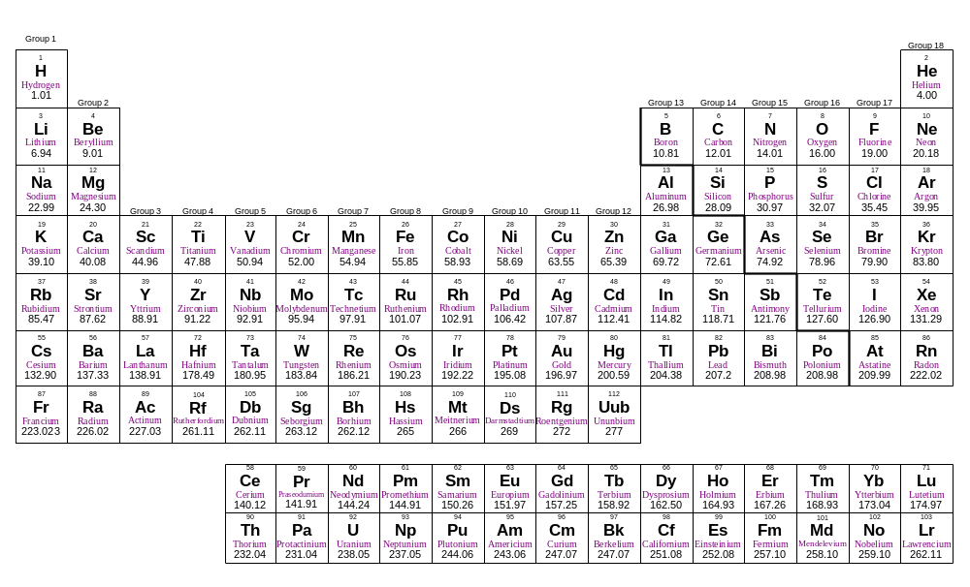
Five basic types of chemical reactions:
A. Synthesis: A + X → AX
B. Decomposition: AX → A + X
C. Single Replacement:
A + BX → AX + B or AX + Y → AY + X

D. Double-Replacement AX + BY → AY + BX

E. Combustion Hydrocarbon (CxHy) + O₂ → CO₂ + H₂O

Activity Series for Metals and Non-metals
Single Replaceent Reactions

Name Symbol  Metals  Lithium Li⁺  Sodium Na⁺  Potassium K⁺  Rubidium Rb⁺  Barium Ba⁺²  Strontium Sr⁺²  Calcium Ca⁺² | Decreasing activity  ↓  reacts with water and acids
Magnesium Mg⁺²  Aluminum Al⁺³  Manganese Mn  Zinc Zn⁺²  Chromium Cr⁺³  Iron Fe  Cadmium Cd⁺²  Cobalt Co⁺²  Nickel Ni⁺²  Tin Sn  Lead Pb  Hydrogen H₂ | reacts with acids replacing hydrogen
Antimony Sb
Bismuth Bi
Copper Cu
Mercury Hg
Silver Ag⁺¹
Platinum Pt
Gold Au

